1. **Radiosity**
   1. **Radiosity**

Radiosity method is completely opposite to image-source technique, which is described in previous chapters (**X**). Radiosity is a two-phase technique that assumes ideal diffuse reflections, whereas the image-source model employs purely ideal specular reflections. In contrast to the image source method, where the sound waves totally reflect in one direction, in radiosity an incoming wave equally scattered in all directions after hitting on a surface. This method also fall under the category of geometric acoustics consisting of elements of energy radiation over distances and via observation angles.

The principle of radiosity technique is illustrated in Figure 2. Initially, the surface of a room is divided into small surface elements known as patches. The sound source placed at some position inside the room casts rays in different directions and these patches collect the energy as illustrated in Figure 2.1 a). From here, the patches start casting rays with the corresponding un-shot energy as shown in Figure 2.1 b). The patches cast its energy according to the highest amount of energy available. This will continue as long as the minimum limit of energy for each patch felt below the limit. The result is a number of patches with the corresponding energy with the arrived time, in other words, an impulse response for each patch. To generate the final impulse response at receiver, just all visible patches are to be processed.

|  |
| --- |
|  |
| **Figure 2.1:** The conceptual diagram radiosity method: **(a)** shooting radiations from the source, **(b)** collecting energy at surface element of the wall and **(c)** re-radiating from the surfaces to the receiver end [**4**] |

One of the important characteristic of radiosity technique is that the sound energy radiated by a surface elements is angle dependent, as implied in radiosity method as basic assumption. In order to include reflections from certain angle of incoming wave a hemisphere of patches is divided into segments, so that the energy can be distributed into diffuse and specular energy as shown in figure 2.2.

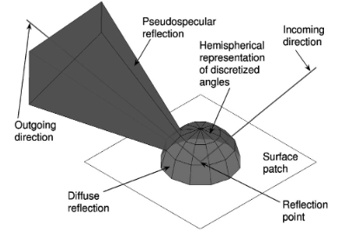

**Figure 2.2:** Hemisphere is divided into solid angles to discretize the directional information[**6**]

* 1. **Advantages**

The advantages of this method are that the number of sound sources affects only the complexity of the initial shooting. Since the initial shooting is a fast operation, modelling multiple sound sources with the same emitted signal at once takes practically the same total time as modelling only one sound source. It is worth noting that the solution stored in patches is view independent, and thus only the ﬁnal gathering operation is required for different receiver positions. Since the ﬁnal gathering operation takes only a few milliseconds in typical models, the receiver position can be changed in real time. When combined with an efﬁcient audio renderer, this solution would allow interactive walk-through auralization in scenes with stationary sound sources and geometry. However, for real time one must pre-compute the radiosity stimulations and then the sound energy at real-time even the listener is allowed to move in the closed space. On the other hand the movement of the source is also possible for real-time application by performing simulation in reciprocal manners.